The 3 Sisters
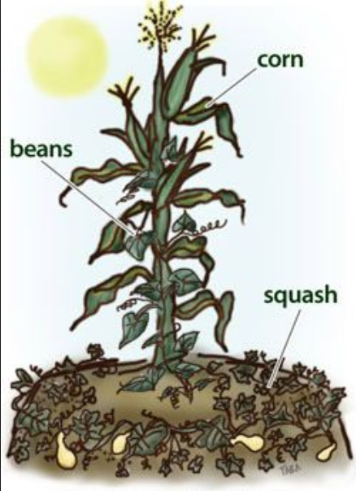

Sister #1: What am I?
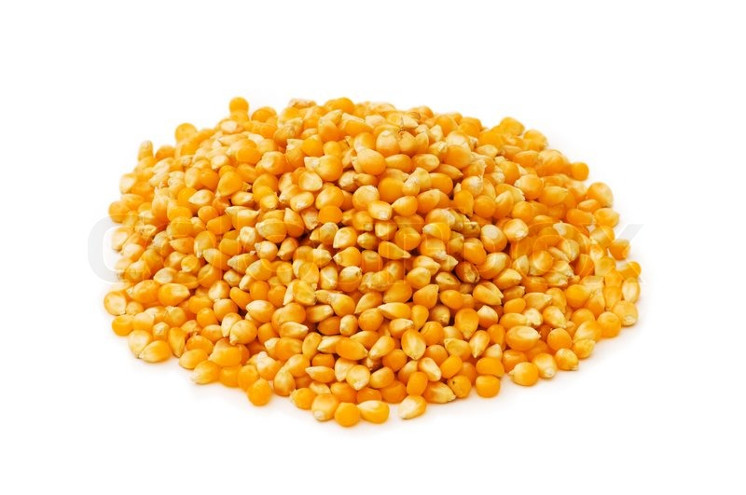
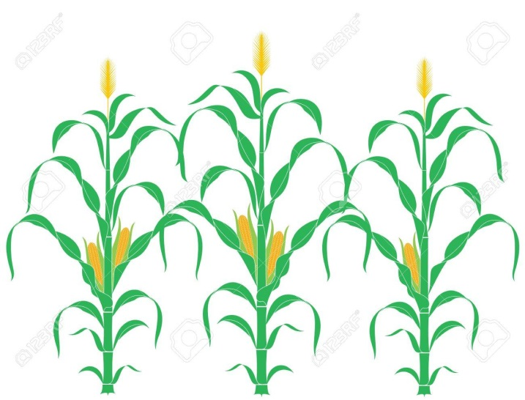
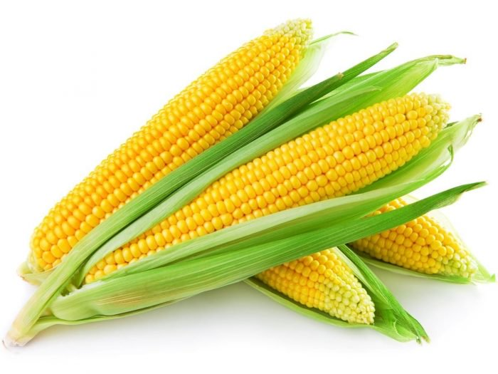
Sister #1
Corn provides a natural pole for bean vines to climb.

Sister #2: What am I?
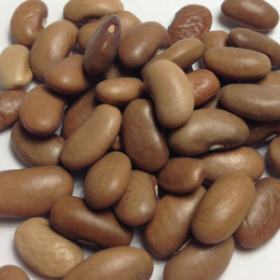
.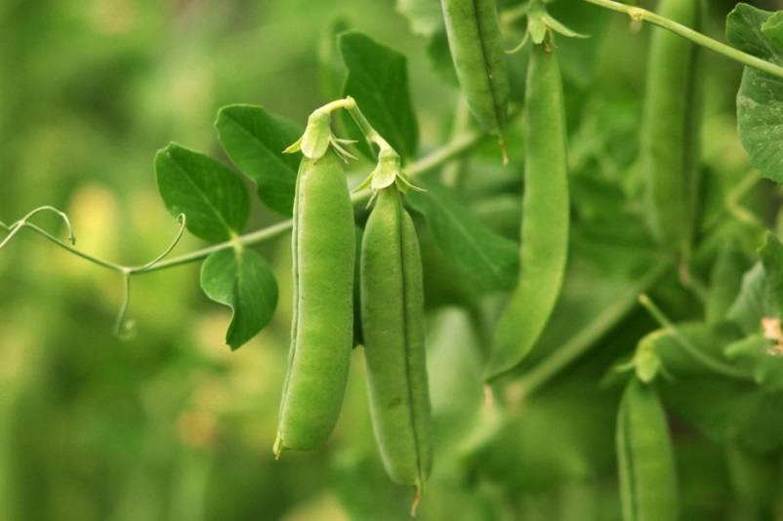

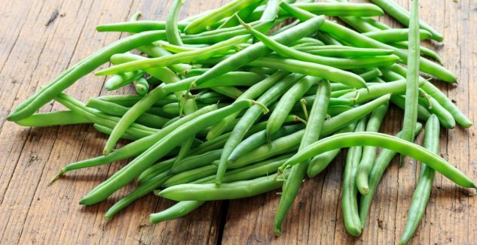
Sister #2
Bean vines help stabilize the corn plants, making them less vulnerable to blowing over in the wind.

Sister #3: What am I?
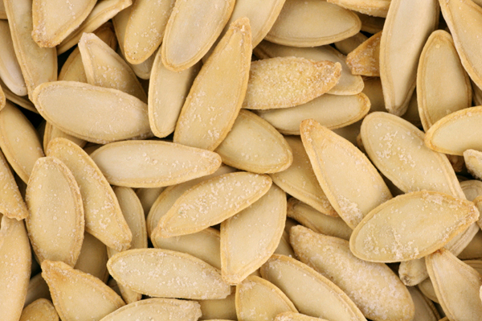
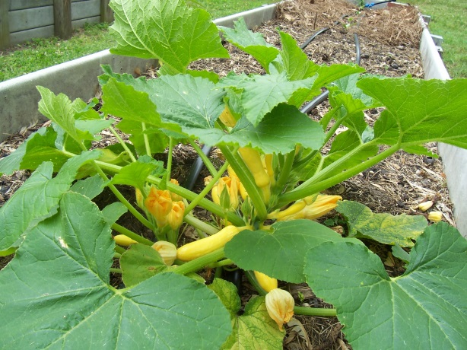
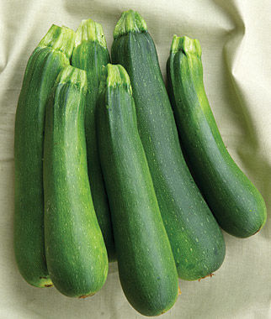
Sister #3
Shallow-rooted squash vines give shade and prevent the soil from evaporating.
Spiny squash plants also help discourage predators from approaching the corn and beans.

