
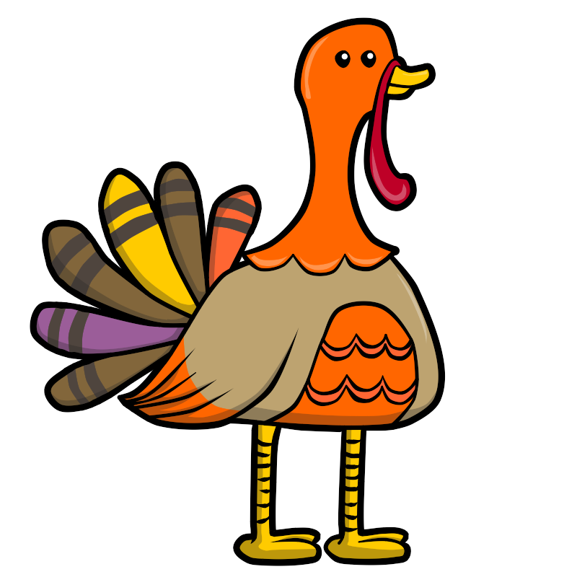
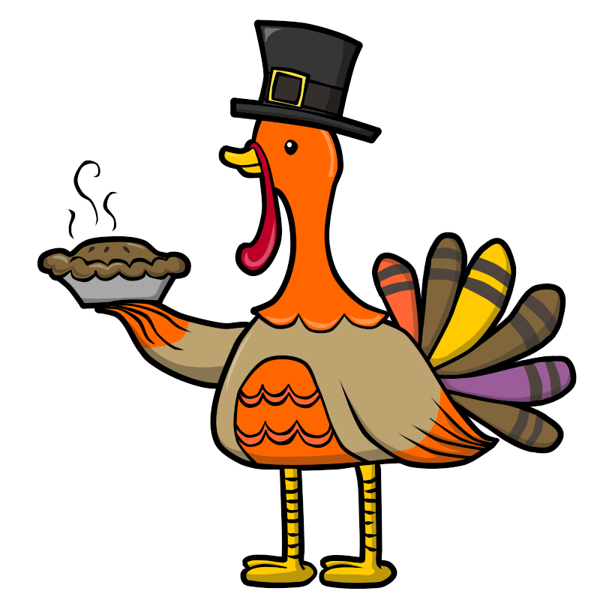

Snack Menu 2018
Monday Tuesday Wednesday Thursday Friday
 |  |  | 1  Fresh Veggie  String cheese with cranberries | 2  Animal Crackers with Milk  Pretzels with Juice
5  Saltines with WOW butter  Goldfish with Juice | 6  Fresh Fruit  Pretzels with Cheese | 7  Cheese Quesadilla  Saltines with Cranberries | 8  Fresh Veggie  Chips and Salsa | 9  Mandarin Oranges  Animal Crackers with Juice
12  SCHOOL CLOSED | 13  Fresh Fruit  Goldfish with juice | 14  Pita Pizza  Saltines with fruit cocktail | 15  Fresh Veggie  Applesauce | 16  Cereal and Milk  Pretzels with Juice
19  Yogurt with animal crackers  Saltines with WOW butter | 20  Fresh Fruit  String Cheese and Juice | 21  Pretzels with cheese  Graham Crackers with milk | 22  SCHOOL CLOSED | 23  SCHOOL CLOSED
26  Cereal and Milk  Graham Crackers and Juice | 27  Fresh Fruit  Pretzels with Cheese | 28  Raisin Bread  Trail Mix | 29  Fresh Veggie  Popcorn with Juice | 30  Goldfish and Juice  Applesauce

