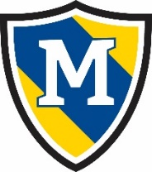
April 2nd- April 8th
 | Thursday | Friday | Monday | Tuesday | Wednesday
AM Snack | Kix Cereal with  Milk | Sausage Biscuit | Cottage Cheese and  Pears | Fruit and Grain Bar,  Milk | Yogurt with  Blueberries
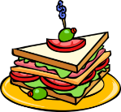  Lunch | Spaghetti w/Meat Sauce,  Green Beans,  Pineapple,  Milk | Cheese Quesadilla,  Corn,  Fruit Cocktail,  Milk | Cheesy Ham and Rice,  Broccoli,  Pineapple,  Milk | Tater Tot Casserole w/Peas & Carrots,  Pears,  Milk | Shepherd’s Pie  w/Mixed Veggies  Pineapple  Milk
PM Snack | Cheez-its  Pears | Tater Tots with  Ketchup | Grahams  Sun Butter | Pepperoni and  Saltines | GORP

