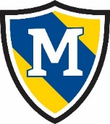
May 21st- May 27th
 | Thursday | Friday | Monday | Tuesday | Wednesday
AM Snack | English Muffins  Sausage | Yogurt  Graham Crackers |  | Chocolate Chip Muffins  Milk | Oatmeal  Milk
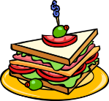  Lunch | Chicken Soft Tacos  w/Lettuce & Cheese,  Pineapple,  Milk | Creamy Pasta Salad,  Peas & Carrots,  Apple Slices,  Milk | Closed for  Memorial Day | Chicken Nuggets, Mashed Potatoes,  Corn,  Milk | Turkey Rollups,  Carrots,  Apple Slices,  Milk
PM Snack | Goldfish  Craisins | Soft Pretzels  Cheese Dip |  | String Cheese  Crackers | Pudding  Vanilla Wafers

