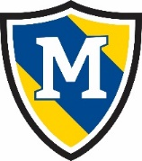
February 18-24th
 | Thursday | Friday | Monday | Tuesday | Wednesday
AM Snack | Waffles  Applesauce | Fig Newtons  Milk | Nutrigrain Bar  Milk | Graham Crackers  Cream Cheese | English Muffins  Jelly
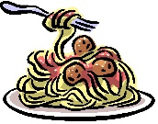  Lunch | Macaroni and Cheese  Green Beans  Bananas  Milk | Chicken Alfredo  Corn  Pineapple  Milk | Pasta Salad w/Cheese Cubes and Pepperoni  Broccoli  Peaches  Milk | Chicken Nuggets  Corn  Applesauce  Milk | Turkey & Cream Cheese Rollups  Carrots  Pineapple  Milk
PM Snack | Saltines  Cheese Slices | Animal Crackers  Bananas | Goldfish  Craisins | Cucumbers  Ranch Dip | Pretzel Sticks  Hummus Dip

