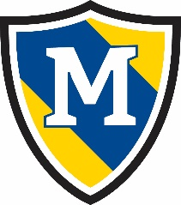
May 10th- May 14th
 | Monday | Tuesday | Wednesday | Thursday | Friday
AM Snack | Cereal Bar  Milk | Strawberry Muffins  Milk | Yogurt  Granola | Bagels  Cream Cheese | English Muffins  w/Jelly
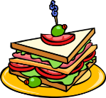  Lunch | Italian Pasta Pepperoni  Cucumbers  Rolls  Pineapple  Milk | Salisbury Steak  Peas and Carrots  Apple Slices  Milk | Turkey and Cheese Sandwich  Banana  Green Beans  Milk | Bean and Cheese Burrito  Corn  Peaches  Milk | Beef Stroganoff  Green Beans  Pineapple  Milk
PM Snack | Pretzel Sticks  Craisins | Vanilla Wafers  Pudding | String Cheese  Crackers | Pepperoni  Crackers | Soft Pretzels  Cheese Dip

