7 Books Perfect for the Night Before the First Day of Preschool

The first day of preschool is the beginning of an exciting new chapter, but it's also a big change for young children. As they get ready to meet new teachers, make new friends, and settle into a new routine, it's natural to have questions or mixed emotions. Reading together before the first day can help children feel more prepared, encourage meaningful conversations, and make the transition to preschool a little easier.
From comforting classics to stories that celebrate confidence and independence, these books are wonderful choices to share before your child's first day of preschool.
The Kissing Hand by Audrey Penn
Starting school can feel a little scary, and Chester the raccoon isn't sure he wants to leave his mother. To help ease his worries, she shares a special family tradition—the "kissing hand"—a loving reminder that she's always with him, even when they're apart. This heartwarming classic offers comfort and reassurance for children who may be feeling nervous about their first day of school.

Llama Llama Misses Mama by Anna Dewdney
Llama Llama is nervous about his first day of school. Everything feels new, and he misses his mama. But as the day goes on, he makes friends, joins in the fun, and discovers that school isn't so scary after all. Best of all, he learns that Mama always comes back.

The Night Before Preschool by Natasha Wing
Told in the familiar cadence of The Night Before Christmas, this fun and reassuring story follows children as they prepare for their first day of preschool. It builds excitement while helping young readers know what to expect.

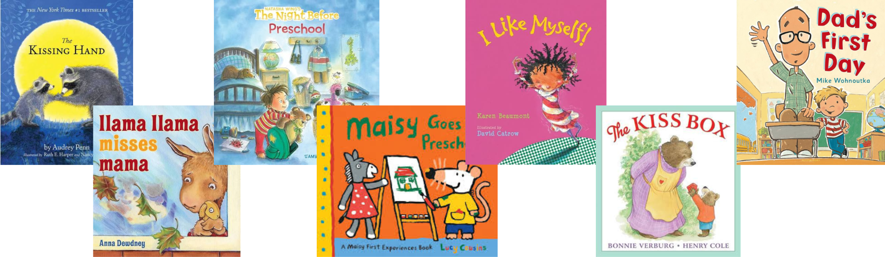

Maisy Goes to Preschool by Lucy Cousins
Follow Maisy as she explores all the fun parts of a preschool day, from creating art and sharing stories to playing with friends and discovering new activities. This cheerful story gives children a glimpse of what to expect during a typical preschool day.

I Like Myself by Karen Beaumont
Through playful rhymes and colorful illustrations, this joyful story encourages children to celebrate what makes them unique. It's an uplifting read that helps build the confidence children need as they head off to school.

The Kiss Box by Bonnie Verburg
When Little Bear worries about being away from his Mama Bear, they create a special kiss box so they can carry each other's love with them wherever they go. This heartwarming story teaches children that even when they're apart, the love they share with their family is always close by, making it a comforting read before the first day of school.

Dad's First Day by Mike Wohnoutka
Oliver can't wait for his first day of school, but his dad has the first-day jitters instead! In this funny role reversal, Oliver reassures his dad that everything will be okay. Filled with laughs and heart, this story reminds children that being brave can help both kids and grown-ups through new experiences.

Books are a great way to start conversations about preschool, but families don’t have to prepare alone. We’re here to help make the transition as smooth as possible through classroom visits, getting-to-know-you opportunities, and support from our caring team. Have questions? Stop by or give us a call anytime. We’re excited to welcome your family!

