Tips for Connecting With Your Child After School
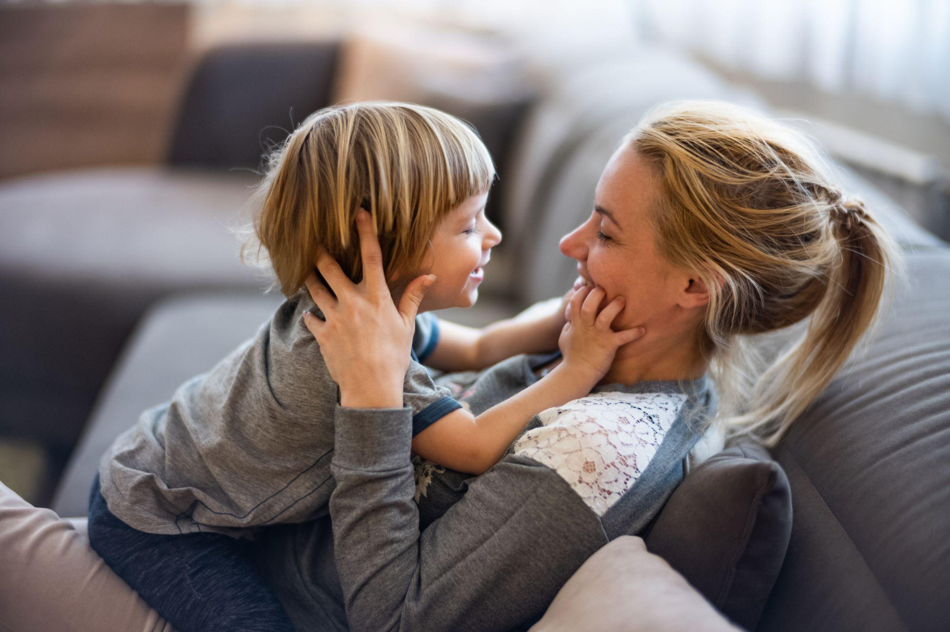
Your child’s preschool day is filled with discovery, friends, and new experiences. After preschool, they may be excited to share about their day, ready to relax, or simply looking for connection with the people they love most. These simple tips can help you create meaningful moments, encourage conversation, and strengthen your connection throughout the rest of the day.

Give a Big, Warm Hello
When you pick up your child, greet them with a huge smile. Wrap your arms around them tightly and let them know you missed them. Say something like, “I’m so happy to see you!” This makes your child feel deeply valued and teaches them that missing someone is completely natural.

Partner With Your Child’s Teachers
We understand how important the partnership between home and school is, and our teachers are a wonderful resource. They are always happy to share highlights about your child’s day. Use these quick chats at pick-up or the notes in your child’s daily report as easy conversation starters on the way home.

Have a Healthy Snack on Hand
Let’s face it—we all get a little grumpy when we’re hungry! A quick, healthy snack for the ride home or right when you get home can take the edge off and help your child recharge after a busy day of learning and play. This is a great time for you to chat with your child.

Allow Time to Reset
Preschool is filled with joyful learning, imaginative play, and meaningful social experiences—all of which take a lot of energy! When children return home, giving them 15 minutes of quiet, unstructured time in a comfortable space can help them transition into the rest of the day.

Have a Snuggle Session!
Settle into a cozy seat and snuggle up! No phones or other distractions. Your child might start telling stories, get playful, or just sink into your hug. Physical closeness helps your child feel secure and connected as they transition from their preschool day to family time.

Go for a Walk
Taking a stroll around the neighborhood is a wonderful way to connect. Walking side-by-side takes away the pressure of eye contact, which often helps kids open up. Point out colorful leaves, listen to the birds, and just enjoy walking together while they share whatever is on their mind.

Ask Specific Questions
Preschoolers are still learning how to express their thoughts and feelings. Instead of a big question like “How was school?”, invite them to share with simple prompts:
- "Who did you play with on the playground today?"
- "Did you build with blocks or make a picture today? Tell me about it!"
- "What made you feel happy today? Did anything make you sad?
Cook Dinner Together
Let your child join you in the kitchen! They can help you cook by handing you ingredients or helping with pouring and mixing, or pretend to cook next to you with play food. Either way, you're spending valuable time together!

The little moments you share after preschool can make a big impact. From conversations to cuddles, each connection helps your child feel loved and supported. Whether you try one idea or all of them, these meaningful interactions can become a special part of your daily routine.

Read these blogs for more helpful tips!
15 Questions to Ask Your Child Instead of “How was School?
Connecting With Your Child After School

Ready for days filled with fun, discovery, and moments your child can’t wait to tell you about? Find a school today!

